Guidelines for your merchandise, including:
Consumer Electronics

Requirements for Packaging Batteries and Devices With Batteries

Protecting Battery Cells
Packaged batteries or cells must be separated in a way to prevent short circuits and damage to terminals.
Protect against short circuit by:
- Packing each battery or each battery-powered device in a fully enclosed inner package made of non-conductive material, such as a plastic blister pack or plastic bag.
- Separating or packing batteries vertically, or side by side to prevent contact with other batteries, devices or conductive material (i.e. metal) in the packaging

Protecting Battery Terminals
If the outer package is not impact-resistant, it should not be used as the sole means of protecting the battery terminals from damage or short circuit. Batteries should be securely cushioned and packed to prevent them from being crushed or from shifting while in transport, which could loosen terminal caps or reorient terminals, producing a short circuit.
Protect your terminals by:
- Ensuring that exposed terminals or connecters are protected with non-conductive caps, non-conductive tape or by other appropriate means
- Packing the battery in rigid plastic packaging
- Constructing the battery with recessed terminals or otherwise protecting the terminals so they will not damage if the package is dropped

Preventing Fires
Any device with installed batteries must be turned off during transport. Protect switches that can be accidentally activated, or remove the batteries and protect the terminals.
Several types of batteries may be regulated as dangerous goods in transportation. Learn more about shipping batteries by selecting the link below.
Shipping Batteries or Devices with Batteries

Interior Cushioning Guidelines

Recommended Cushioning:
Foam Sheeting
Foam sheeting is a lightweight, soft, resilient material made of thin polystyrene or polyethylene material. It comes in a variety of thicknesses, but sheeting with a minimum thickness of 1/4-inch-thick (0.64 cm) is recommended.
Foam sheeting provides cushioning for items, and can be wrapped around almost any product, regardless of shape or size. When using foam sheeting, include several layers to ensure that the entire product is cushioned, paying close attention to protecting corners and edges. When packing multiple items, wrap each item separately. Fragile items need suitable separation from each other, and from the corners, sides, top and bottom of the box.
Each item should be surrounded by at least two inches (5.08 cm) of sheeting and placed two inches (5.08 cm) away from the box walls. This prevents product-against-product damage and protects the contents from shock and vibration, which can pass from the outside of the box to the contents. Use enough sheeting to ensure that the contents cannot move when you shake the box.
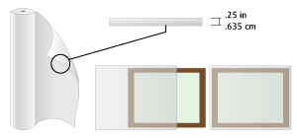

Alternate Cushioning:
Foam-in-Bag
Foam-in-place or foam-in-bag pads are formed by a chemical mixture that expands and forms a protective mold around contents.
Foam-in-place or foam-in-bag pads form and mold around any product. These cushions work well to support corners and protect edges.
For maximum effectiveness, the foam-in-place or foam-in-bag must be evenly distributed around the items in order to protect the product. Since this material is offered in varying densities it is important to select the most appropriate foam to meet the requirements of the product. This can range from a low grade void fill for lightweight items to a high-performance cushioning.
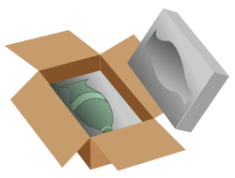

Alternate Cushioning:
Double Box
Double-boxing or over-boxing is an effective method of protecting fragile items where the packaging is not suitable for shipment through carriers, such as UPS, that use manual and automated distribution systems.
Make sure that the original packaging is in good condition and intact. Cracked or broken foam pieces should be replaced or repaired. Make sure that the item cannot move in the original packaging.
Select a new shipping container with the strength recommended that is at least six inches (15.24 cm) larger than each of the original box's dimensions. Fill the bottom of the new shipping container with two to three inches (5.08 cm to 7.62 cm) of loose fill (for merchandise up to 10 lbs/4.54 kg), bubble sheeting (for merchandise up to 50 lbs/22.68 kg), foam-in-place, polyethylene foam pads, or other dunnage material.
Place the original manufacturer's box on top of the cushioning material in the centre of the shipping container and place cushioning around the remaining five sides. Seal the flaps of the box with the recommended material and method.
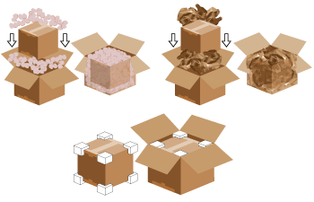

Product Placement Guidelines
Separate the products from one another with a minimum of 2 inches (5.08cm) of recommended materials.
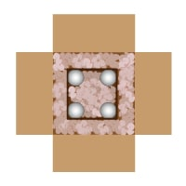
Separate the products from the walls of the container with a minimum of 2 inches (5.08 cm) of recommended materials.

General Guidelines
Exterior Carton Guidelines
Make sure your box has a seal reflecting this number or is an equivalent.
Recommended Container:
275 Burst Strength Box
Use a new, single-wall, corrugated shipping container with a 275-lbs-per-square-inch burst strength, or non-U.S. equivalent.
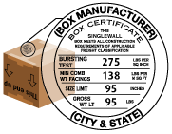
Alternative Container:
55 ECT Box
Use a new, single-wall, corrugated shipping container with a 55-lbs-per-inch edge crush test (ECT) strength, or non-U.S. equivalent.
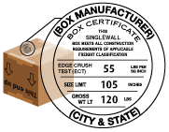
Alternative Container:
350 Burst Strength Box
Use a new, single-wall, corrugated shipping container with a 350-lbs-per-square-inch burst strength, or non-U.S. equivalent.
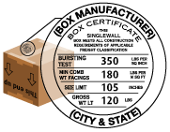
Closure Guidelines
Seal the flaps of your shipping container using six strips of pressure-sensitive poly tape. Use a strong tape with a minimum width of two inches (48 mm). For regular slotted containers (RSC) where the flaps meet in the centre, apply three strips of tape to both the top and bottom of the box, so the middle and two edge seams are sealed. For corrugated containers where the flaps overlap (FOL), apply three strips of tape to both the top and bottom of the box, so the three edge seams are sealed. Do not use masking tape, cellophane (office) tape, duct tape, string or paper over-wrap.
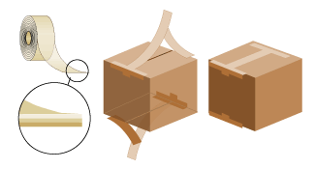
Shipping Label Placement Guidelines
Place the shipping label on the top of the package. To avoid confusion, make sure only one address is visible on the package. If you are using a packing slip, place it on the same surface as the address label.
Avoid placing the label over a seam or box closure or on top of box sealing tape.
Remove or cross out old labels or markings on used boxes.
Place a duplicate label or other form of identification inside your package.
Note: If you are using a mailing tube, place the label horizontally, with each end of the label pointing toward the ends of the tube, so the bar code can be scanned.
Always include your complete return address, including full street address and postcode.
Always include the recipient's postal code with the complete street address.
Make every effort to obtain a street address. If using a P.O. Box address, include the recipient's telephone number on the label. Note that any packages addressed to a P.O. Box may be delayed, are not covered by any UPS Service Guarantee, and require an address correction charge. Army Post Office (APO) and Fleet Post Office (FPO) address are not accepted.
For international shipments, include a contact name, telephone number, and postal code.
